Title: How has access to and participation in parkrun in England changed from 2010 to 2019? A longitudinal ecological study.

Potential Journals:

1. International Journal of Behavioral Nutrition and Physical Activity
2. Journal of Physical Activity and Health
3. BMJ Open
4. Health & Place

Authors: Robert Smith*1, Paul Schneider*1, Rami Cosulich1, Helen Quirk1 Alice Bullas, Steve Haake, Elizabeth Goyder1.

*Equal Contributors.

Institutions:

1. School of Health and Related Research, University of Sheffield, Regents Court, Sheffield, S1 4DA, UK.
2. Advanced Wellbeing Research Centre, Sheffield Hallam University, Olympic Legacy Park, Sheffield, S9 3TU, UK

Keywords: parkrun, Physical Activity, Ethnic Density, Deprivation.

Author Roles:

Smith R: Conceptualization, Data Curation, Formal Analysis, Investigation, Methodology, Project Administration, Software, Visualization, Writing – Original Draft Preparation, Writing – Review & Editing;

Schneider P: Conceptualization, Data Curation, Formal Analysis, Investigation, Methodology, Project Administration, Software, Visualization, Writing – Original Draft Preparation, Writing – Review & Editing;

Cosulich R: Writing – Review & Editing;

Quirk H: Project Administration, Resources,

Bullas A: Project Administration, Resources;

Haake S: Project Administration, Resources,

Goyder E: Supervision, Writing – Review & Editing

Competing Interests: R.S. and P.S. have no competing interests. S.H. is chair, A.B. and H.Q are deputy chairs, and L.G. is a member of the parkrun research board.

Grant information: R.S., P.S. & R.C. are joint funded by the Wellcome Trust Doctoral Training Centre in Public Health Economics and Decision Science [108903] and the University of Sheffield. The funders had no role in study design, data collection and analysis, decision to publish, or preparation of the manuscript.

Data Availability:

Underlying Data: < INSERT ZENODO LINK >.

Software availability: <INSERT ZENODO LINK>.

Acknowledgements: We would like to thank Mike Graney (Head of Analysis at parkrun) and Chrissie Wellington (Global Head of Health and Wellbeing at parkrun) for providing LSOA parkrun participation data.

# 

# Abstract

Objectives

To conduct a longitudinal ecological analysis of the geographic access to and participation in free weekly outdoor physical activity events (“parkrun”) in England from 2010 to 2019, and the socioeconomic disparities therein.

Methods

We calculate the distance to the nearest operational parkrun event for each English Lower Layer Super Output Area each month from January 2010 to December 2019. We then report the trends in access to and participation in parkrun by Index of Multiple Deprivation quintile. We also report trends in the Relative Index of Inequality (RII) by deprivation for participation and access. We go on to investigate trends in the determinants of parkrun participation between the years 2010 and 2019, using multivariable Poisson regression models. We conclude by reporting the results of a random effects regression model including year as a covariate.

Results

Mean distance to the nearest parkrun event improved from 34.1 km in the year 2010, to 4.9 km in 2018. Geographic access has generally tended to be better for the most deprived communities than other communities. Participation rates increased exponentially from 2010 to 2013 before slowing to a linear growth. Participation over the period exhibits a clear socioeconomic gradient, with deprived communities having much lower participation rates. Parkrun participation rates became more equitable between 2010 to 2013 (RII improved from 189 to 39), before stabilising at an RRI of around 35 until the year 2019.

Conclusions

Access to and participation in parkrun events has increased considerably over the past 10 years, whereby most of the improvement occured between 2010 to 2013, after which the growth slowed down. Despite parkrun’s ambitions of creating inclusive sporting events and engaging with deprived communities, the socioeconomic gradient in participation rates remained high and stable since 2013. Gaining a better understanding of the reasons why parkrun grew so quickly from 2010 to 2013 may be useful for other physical activity movements. Further analysis of the relatively lower participation rates in December by those from communities with higher socioeconomic deprivation may be important in developing initiatives to encourage physical activity in these communities.

# Introduction

In 2004, a group of runners started a small event called the ‘Bushy Park Time Trial’ in Bushy Park, London. At the time of writing there have been a total of XXXmillion individual runs, many of whom were not previously engaged in distance running prior to parkrun (@reece2019bright, @stevinsonhickson). Early research showed that regular participants in parkrun experienced increases in weekly physical activity levels, improved fitness, and reported health benefits such as better weight control and mental wellbeing (@stevinsonhickson). This has led to parkrun being identified as an exemplar intervention in the WHO Global Action Plan on Physical Activity 2018–2030 (@world2019global), and by the Royal College of General Practitioners (RCGP) as a form of social prescribing aimed at increasing patient physical activity.

However, as a grass-roots, citizen led community organization, parkruns have generally been established by enthusiastic volunteers in their local community. As a result there is a risk that as with other public health interventions, parkrun events may not be as available, or as well attended in deprived communities as in less deprived areas (@bull2014interventions). Our previous work showed that, in 2018, despite similar geographical access to parkrun events (@smith2020), more deprived communities and communities with higher ethnic density had lower participation rates than less deprived areas with lower ethnic density.

This paper combines a rich dataset containing the number of parkrun finishers from each of the 32,844 Lower layer Super Output Areas (LSOAs) in England for each week over the ten year period from 2010 to 2019, with Office for National Statistics data on LSOA characteristics and parkrun event data, to better understand the trends in access to and participation in parkrun. We then repeat our previous analysis of the socioeconomic determinants of parkrun participation (previously for 2018) for each year from 2010 to 2019.

# Methods

## Ethical statement

Ethical approval was obtained from the Sheffield Hallam University Ethics Committee (ER10776545). We did not collect any personal information, but only used aggregate secondary data. The parkrun Research Board approved this research project, and three of its members (AMB; EG, SSJH) were actively involved in it.

## Data Sources and variables

Data on the number of finishers from each of the 32,844 LSOAs on the 522 Saturdays in the years from 2010-2019 inclusive was obtained from parkrunUK. The geographical location and start date for each parkrun event was obtained from the parkrunUK website. The rest of the data was obtained from the ONS Descriptions of variables and sources are provided in Table 1 below. All underlying data is provided open source (link github). In the open source data number of finishers is provided aggregated by month and by year as used in the remainder of the analysis.

#### Table 1. Variables & sources of data in analysis

|  |  |  |
| --- | --- | --- |
| Variable | Description | Source |
| run_count | number of finishers per month/year from each LSOA in England from 1st January 2010 to 31 December 2019. | parkrunUK |
| run_rate | derived from run_count and LSAO populations | derived |
| imd | 2015 Index of Multiple Deprivation scores for each LSOA | [ONS](https://assets.publishing.service.gov.uk/government/uploads/system/uploads/attachment_data/file/835115/IoD2019_Statistical_Release.pdf) |
| total_pop | total number of individuals in each LSOA | [ONS](https://www.ons.gov.uk/peoplepopulationandcommunity/populationandmigration/populationestimates/datasets/lowersuperoutputareamidyearpopulationestimates) |
| pop_density | population density for each LSOA | ONS](https://www.ons.gov.uk/peoplepopulationandcommunity/populationandmigration/populationestimates/datasets/lowersuperoutputareapopulationdensity) |
| perc_bme | Ethnic Density: percentage of population non-white-british | [ONS](https://www.ons.gov.uk/peoplepopulationandcommunity/culturalidentity/ethnicity/datasets/2011censussmallpopulationtablesforenglandandwales) |
| mn_dstn | distance from LSOA centroid to nearest parkrun (derived) | derived from [ONS](<http://census.ukdataservice.ac.uk/get-data/boundary-data.aspx>) & parkrunUK. |
| perc_non_working_age | derived from ONS data on age-groups in each LSOA | [ONS](https://www.ons.gov.uk/peoplepopulationandcommunity/populationandmigration/populationestimates/datasets/lowersuperoutputareamidyearpopulationestimates) |

LSOA, Lower layer Super Output Area; ONS, Office for National Statistics.

### Access

We used the method described in [@schneider2019] to calculate, on the 15th of each month of the period, the distance to the nearest parkrun event (in existence at that time) for each of the LSOAs.

### Parkrun participation

### 

### Index of multiple deprivation

### 

## Data Analysis

The open source dataset contains data for all 32,844 English LSOAs for each month from January 2010 to December 2019, including only events which took place on Saturdays.

### Descriptive statistics

We investigate longitudinal trends in access and participation by IMD quintile using descriptive statistics and charts. We report both the number of finishers per 1000 persons and the mean distance to nearest event for each of the Index of Multiple Deprivation Quintiles (IMD) by month and year.

### Relative Index of Inequality

The relative index of inequality (RII), is used to summarise inequality in geographic access and participation over time. The RII is a strictly non-negative regression-based index which is commonly used to describe the size of the effect of socioeconomic status on an outcome (@mondor2018income). We calculate the RII, as the ratio of predicted outcomes using a univariate poisson regression model with IMD as the sole predictor, between the most deprived and least deprived LSOAs, for both access and participation for each month over the period. An RII > 1 means that less deprived areas are predicted to have a higher outcome (e.g. less participation and greater distance to the nearest parkrun event).

### Determinants of access and participation over time

We conclude by replicating our previous analysis of the determinants of community level parkrun participation, using a log-link pseudo-Poisson regression model for aggregate data for each year from 2010 to 2019. As control variables we use: population density, ethnic density, distance to nearest event and percent of the population of non-working age. Total population was used as an offset. We report mean coefficient estimates and 95% confidence intervals for each year.

All analysis was undertaken in R version 4.0.2 (2020-06-22). All code is available online here: <INSERT GITHUB LINK>

# Results

## Descriptive Statistics

The monthly dataset contains 3,547,152 rows, one row for each unique LSOA each month with a mean IMD score of 21.7 (IQR = 9.65 - 30.07), mean total population 1627 (IQR = 1437 - 1750), mean percent non-working age of 41.52 (IQR = 38.33-45.98) mean ethnic density of 13.78% (IQR = 2.26% - 16.68%) mean population density of 4.49 thousand persons per square kilometer (IQR 1.29 - 5.92) & mean distance to nearest event of 12.24km (IQR 2.89km - 13.43km).

--- Table 1 showing some descriptive stats of important variables that do not change over time ---

Figure 1 shows the mean linear geographic distance to the nearest parkrun event (i.e. geographic access) for each of the IMD quintiles (and overall in black) over time. Geographic access rapidly in the first few years (from 34km in 2010 to 10km in 2013), but due to diminishing returns from additional events, improvements in access slowed in later years (to 5km in 2019). Geographic access had no clear socioeconomic gradient from 2010 to 2013, but from 2013 onwards was generally better in more deprived areas.

#### **Figure 1. Mean geodisc distance to the nearest parkrun event on the 15th of each month from January 2010 to December 2019, by IMD quintile.**

|  |  |  |  |  |  |  |  |  |  |
| --- | --- | --- | --- | --- | --- | --- | --- | --- | --- |
| Year | 2010 | 2011 | 2012 | 2013 | 2014 | 2015 | 2016 | 2016 | 2018 |
| Overall | 34.09 (0.06) | 20.79 (0.04) | 14.53 (0.03) | 10.21 (0.02) | 7.93 (0.01) | 6.66 (0.01) | 5.79 (0.01) | 5.27 (0.01) | 4.85 (0.01) |
| Most deprived 20% | 30.57 (0.13) | 16.84 (0.08) | 11.21 (0.05) | 7.72 (0.03) | 6.02 (0.02) | 5.03 (0.02) | 4.29 (0.01) | 3.86 (0.01) | 3.60 (0.01) |
| 2 | 35.64 (0.17) | 21.52 (0.11) | 14.86 (0.07) | 10.19 (0.05) | 7.72 (0.03) | 6.36 (0.02) | 5.35 (0.02) | 4.82 (0.02) | 4.43 (0.02) |
| 3 | 38.82 (0.15) | 23.94 (0.1) | 16.9 (0.07) | 11.95 (0.04) | 9.18 (0.03) | 7.77 (0.03) | 6.73 (0.02) | 6.05 (0.02) | 5.61 (0.02) |
| 4 | 35.52 (0.13) | 22.2 (0.08) | 15.7 (0.06) | 11.12 (0.04) | 8.61 (0.03) | 7.29 (0.02) | 6.39 (0.02) | 5.88 (0.02) | 5.44 (0.02) |
| Least deprived 20% | 29.92 (0.1) | 19.46 (0.06) | 13.98 (0.04) | 10.09 (0.03) | 8.11 (0.02) | 6.85 (0.02) | 6.18 (0.02) | 5.73 (0.02) | 5.16 (0.01) |

*1 = most socioeconomically deprived quintile , 5 = least socioeconomically deprived quintile.

Figure 2 below shows the number of finishers per 1000 persons for each IMD quintile, and overall, for each month in the study period. The participation rate showed a general positive trend (ignoring seasonal fluctuations) in all deprivation quintiles. In all cases participation can be seen to increase exponentially from 2010 to 2013, before exhibiting linear growth from 2014 to 2019. There is a clear difference between the participation rates for different IMD deprivation quintiles, with the most deprived 20% of LSOAs having participation rates that have been between min% and max% lower than of the least deprived 20% of LSOAs. By 2019 the most deprived quintile of the population had similar participation rates as the least deprived did in 2013, six years earlier.

#### Figure 2. Mean monthly parkrun finishers per 1000 persons from January 2010 to December 2019, by IMD quintile.

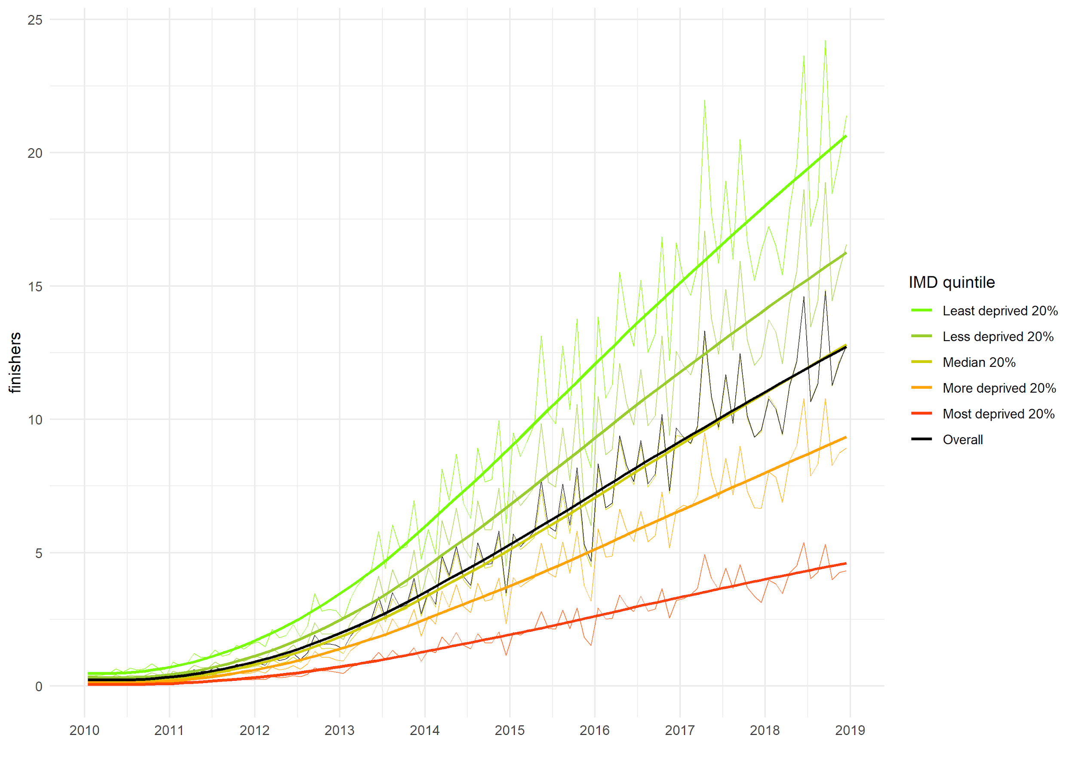

|  |  |  |  |  |  |  |  |  |  |
| --- | --- | --- | --- | --- | --- | --- | --- | --- | --- |
| Year | 2010 | 2011 | 2012 | 2013 | 2014 | 2015 | 2016 | 2016 | 2018 |
| Overall | 0.26 (0) | 0.6 (0) | 1.23 (0) | 2.71 (0.01) | 4.38 (0.01) | 6.13 (0.01) | 8.26 (0.02) | 10.43 (0.02) | 11.8 (0.02) |
| Most deprived 20% | 0.07 (0) | 0.18 (0) | 0.42 (0) | 1 (0.01) | 1.61 (0.01) | 2.21 (0.01) | 2.97 (0.01) | 3.82 (0.02) | 4.3 (0.02) |
| 2 | 0.15 (0) | 0.37 (0) | 0.81 (0.01) | 1.93 (0.01) | 3.14 (0.02) | 4.32 (0.02) | 5.85 (0.03) | 7.53 (0.03) | 8.66 (0.03) |
| 3 | 0.21 (0) | 0.52 (0.01) | 1.1 (0.01) | 2.54 (0.02) | 4.24 (0.02) | 5.89 (0.03) | 8.12 (0.03) | 10.37 (0.04) | 11.83 (0.04) |
| 4 | 0.34 (0.01) | 0.77 (0.01) | 1.55 (0.01) | 3.37 (0.02) | 5.58 (0.03) | 7.87 (0.03) | 10.65 (0.04) | 13.35 (0.04) | 15.08 (0.05) |
| Least deprived 20% | 0.54 (0.01) | 1.17 (0.01) | 2.28 (0.02) | 4.69 (0.03) | 7.35 (0.03) | 10.36 (0.04) | 13.72 (0.05) | 17.07 (0.05) | 19.14 (0.05) |

*1 = most socioeconomically deprived quintile , 5 = least socioeconomically deprived quintile.

Standard errors in parentheses.

## Trends in Relative Index of Inequality in Access

As shown in figure 3, access, measured as the geodesic distance to the nearest parkrun event, was relatively equitable in 2010 but became increasingly inequitable, in favour of more deprived communities, until 2017. By 2017 the **least deprived** LSOA had almost 3.5 times the predicted linear distance to the nearest parkrun event of the most deprived LSOA. This fell to approximately 2.75 by the end of 2018.

#### Figure 3. Relative Index of Inequality in geodisc access to parkrun by month from January 2010 to December 2019.

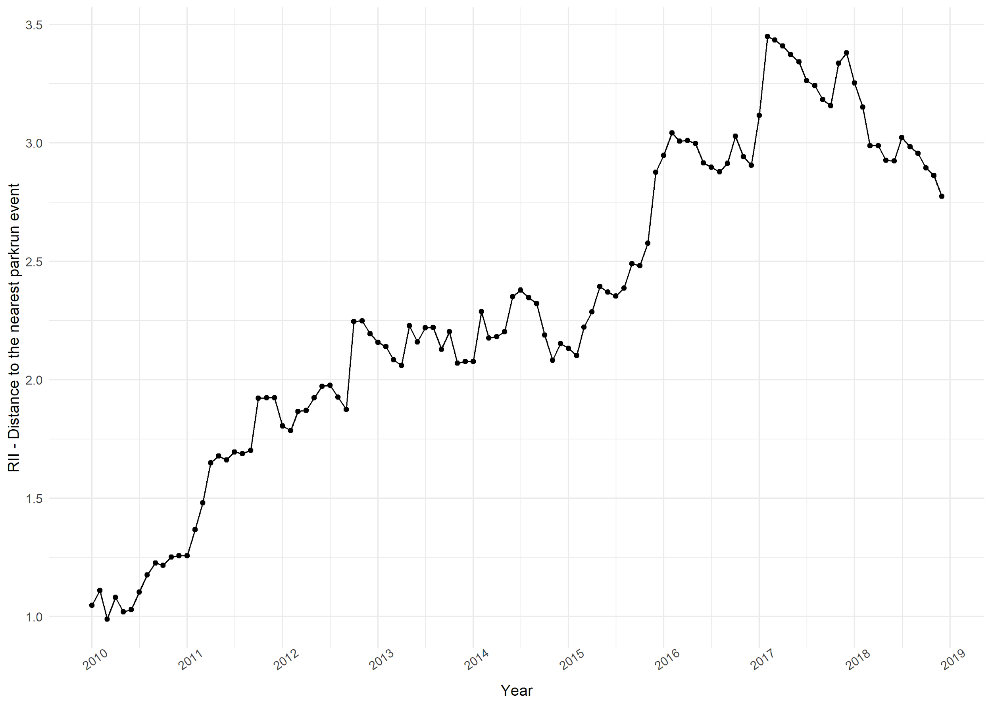

|  |  |  |  |  |  |  |  |  |  |
| --- | --- | --- | --- | --- | --- | --- | --- | --- | --- |
| Year | 2010 | 2011 | 2012 | 2013 | 2014 | 2015 | 2016 | 2017 | 2018 |
| RII | 1.109 | 1.602 | 1.951 | 2.145 | 2.224 | 2.365 | 2.957 | 3.304 | 2.976 |

For the RII in participation, we observed a different trend: Initially in 2010, the socioeconomic gradient of parkrun participation was extremely steep, regression based predictions of participation rates (RII) were 189 times higher in the least deprived LSOA compared to the most deprived LSOA. Subsequently, the RII fell from 2010 to 2013, at which point the measure stabilised such that the least deprived area had around 35 times the predicted number of finishers as the most deprived area. Figure 4 shows the RII for participation. A RII greater (less than) than 1 means that less deprived areas have higher (lower) predicted participation rates. Moreover, we found strong seasonal trends from the year 2013 onwards, with December being the most inequitable and January the least inequitable months.

#### Figure 4. Relative Index of Inequality in monthly parkrun participation by month from January 2010 to December 2019.

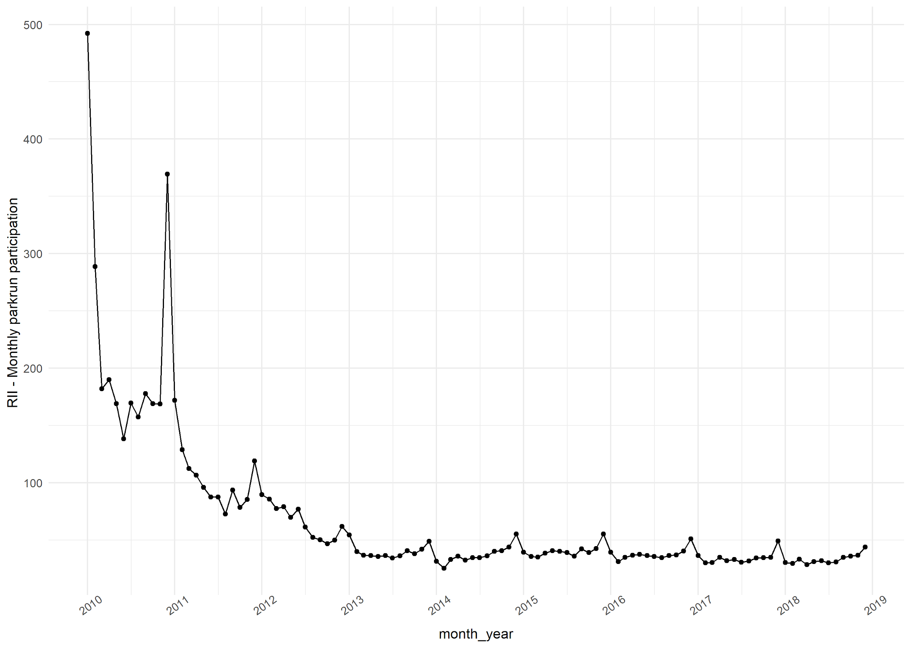

|  |  |  |  |  |  |  |  |  |  |
| --- | --- | --- | --- | --- | --- | --- | --- | --- | --- |
| Year | 2010 | 2011 | 2012 | 2013 | 2014 | 2015 | 2016 | 2017 | 2018 |
| RII | 189.3 | 97.3 | 61.8 | 39.0 | 36.5 | 39.6 | 37.5 | 33.9 | 32.9 |

## Poisson regression model of the determinants of participation from 2010 to 2019.

The results of the Poisson regression models, one for each year from 2010 to 2019, are displayed in Table 2 below. The dependent variable is number of finishers, and the independant variables include the LSOA Index of Multiple Deprivation (IMD) score, Ethnic-Density (%), Population Density (per-square km), distance to nearest event (in km) and percent of the population non-working age (%).

The Index of Multiple Deprivation regression coefficient is negative in every year over the ten year period (i.e. more deprived areas have lower parkrun participation). However the coefficient on IMD has increased throughout from -0.047 in 2010 to -0.035 in 2018, meaning the effect of a single unit increase in IMD score (controlling for covariates) reduced from -4.6% in 2010 to -3.4% in 2018. Most of this change occurred between 2010 to 2013. It is also worth noting that the coefficient on the Ethnic Density variable has also increased over time. The effect of a 1% increase in ethnic density decreased from a 2% reduction in participation in 2010 to a 1.3% reduction in 2018. (i.e. the effect of ethnic density, the percentage of non-white-british persons in the community, on parkrun participation has fallen over time).

#### Table 2. Results of the Poisson log-link generalised linear model for each year from 2010 to 2019.

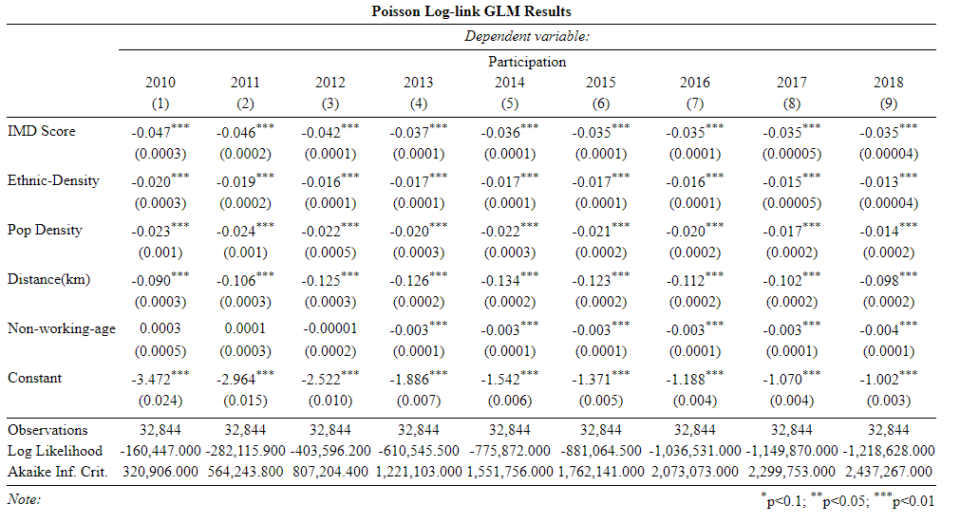

# Discussion

This article aimed to investigate the trends in community level access to and participation in parkrun, a community running event, in England between 2010 and 2019. This fills an important gap in the literature as an exemplar of how community events to increase physical activity can grow, and adds to our understanding of how that growth occurs in different communities. The incredibly rich dataset provided by parkrunUK shows that access and participation improved significantly over the ten year period. However these improvements exhibited diminishing returns (initial improvements were much bigger than later improvements). This is to be expected for access, since the second event in a region will generally result in much lower improvements in access.

Geographic access to parkrun events was equitable in 2010, more deprived communities had similar distances to their nearest event as less deprived communities. However, as parkrun grew, more events were created in areas with high deprivation (e.g. deprived coastal towns and less affluent cities), than in less deprived areas such as rural village locations. This led to the phenomenon we see today, whereby geographic access to parkrun is much better for more deprived areas. Perhaps because of these disproportionate improvements in access for more deprived communities, participation in these communities also increased disproportionately until 2013.

Despite similar or even better geographic access to parkrun events for more deprived communities, we found a strong socioeconomic gradient in participation rates. Throughout the study period, LSOAs in the least deprived quintile had between X and Y times higher participation rates than the most deprived quintile, and after a dramatic improvement between 2010 and 2013, the RII remained at a stable level of 35. This result was confirmed by the multivariable analysis of the determinants of parkrun participation, which showed only marginal changes in the relationship between IMD and parkrun participation after 2013. Despite the continous growth of parkrun in England, in 2019, the population residing in the least deprived quintile have over 6 times the participation rates of the population residing in the most deprived quintile.

In our previous paper, we showed that in 2018, areas with higher deprivation, and areas with higher ethnic density had lower parkrun participation rates (@smith2020). In this paper we replicated this analysis for each year from 2010 to 2018. We found that, as with the descriptive statistics & univariate analysis (RII), the period can be split into two distinct phases: from 2010 to 2013 the effect of deprivation (IMD) reduced, and from 2013 to 2019 the effect remained stable. However, the effect of ethnic density appears to have declined over the entire period. Nevertheless the results for 2016, 2017 and 2019 are similar enough to validate our findings for 2018.

*---- insert para on how this fits with the wider lit on parkrun, possibly suggesting that studies have overemphasised the inclusivity and the potential of parkrun to play a role for public health? ---*

An unexpected and potentially interesting and unexpected finding is the distinct increase in RII in December. This effect is glaring in Figure 4 - inequity in participation is much higher in December than any other month. We know from anecdotes that families are more likely to attend parkrun with extended family over Christmas, if this is a ‘middle-class’ behaviour this could be the driver of this phenomenon. Further research could explore why inequality in participation is lower in certain months, as a means of developing interventions to try to increase engagement with more deprived communities.

These findings are both encouraging and discouraging. While the overall growth in access and participation has increased year on year, that growth has slowed down. Also, despite improvements to access for those in more deprived communities, participation has remained substantially lower in these areas than in less deprived areas. Further research is necessary to better understand why some communities are more engaged in parkrun than others. Understanding why engagement differs more or less at different times of the year may be a simple first step in this analysis, but a more robust mixed-methods approach to identifying modifiable factors which influence participation is more likely to generate feasible interventions. This could have a wider impact than just parkrun, since the mechanisms which affect participation in the weekly 5k running event are also likely to influence physical activity participation and/or engagement in community events in general.

## Limitations

The coefficients for 2018 do not match the coefficients of our previous paper (@smith2020). There are several reasons for this; firstly this analysis includes the full year, whereas the 2018 study included only the period to 10th December, secondly parkrun updated their database, which led to some (seemingly) random variation between the two datasets, and finally we only include events held on a Saturday in this analysis, whereas in the previous analysis we included all parkrun events.

The measure of access used in this study, linear (geodesc) distance, does not measure the ability of different groups to attend events. A 5 km distance may be more difficult to transverse in a city than for those with a car in rural areas. A model which uses estimates of travel time using travel distance and predicted transport mode may yield a better proxy for access, and adding a consideration of other forms of access (e.g. travel expense) may improve our understanding of the determinants of participation.

The Relative Index of Inequality (RII) is a commonly used measure of inequity used where the independent variable varies linearly (@sergeant2006relative). In most years the relationship was relatively linear (CHECK THIS). We have reported the RII throughout using predicted participation from the least and most deprived LSOA based upon IMD Score.

The use of ethnic density in this analysis does not allow us to determine variation in participation by areas with higher percentages of particular ethnic groups. Future analysis could use more detailed ONS data on the LSOA ethnicity to better understand whether the effect is similar for all minority ethnic groups. All data & code is available open source to enable others to build upon this work.

There are also several limitations that are similar from our previous analysis for 2019 (@smith2020). Firstly, the data provided by parkrun gives the number of finishes by LSOA. The number of finishes tells us nothing about the number of unique runners, and one runner undertaking 5 runs is counted the same as five runners undertaking 1 run each. We feel confident this is a satisfactory simplification. Also important is that this is an ecological study at the level of the LSOA. As before we have been careful to state that effects exist at the level of the community, not necessarily the individual, so as not to commit an ecological inference fallacy.

# Conclusion

Access to and participation in parkrun events has improved over the past 10 years. The period can be split into two distinct phases: from 2010 to 2013 participation and access increased exponentially and inequality in participation fell dramatically, and from 2013 to 2019 participation increased linearly, and inequality in participation remained stable.

The findings of this study suggest that improvements in participation are likely to be linear, but that without further intervention the gap between more and less deprived communities is unlikely to close.

Mixed methods research combining the power of the rich participation dataset provided by parkrun with a deeper understanding of the issues on the ground is essential for shaping effective interventions to boost participation overall, but particularly in socio-economically deprived communities.

# References

In bibtex format please (e.g.):

@article{schneider2019should,

title={Where should new parkrun events be located? modelling the potential impact of 200 new events on socio-economic inequalities in access and participation.},

author={Schneider, Paul P and Smith, Robert A and Bullas, Alice M and Bayley, Thomas and Haake, Steve SJ and Brennan, Alan and Goyder, Elizabeth},

journal={MedRxiv},

pages={19004143},

year={2019},

publisher={Cold Spring Harbor Laboratory Press}

}

@article{bull2014interventions,

title={Are interventions for low-income groups effective in changing healthy eating, physical activity and smoking behaviours? A systematic review and meta-analysis},

author={Bull, Eleanor R and Dombrowski, Stephan U and McCleary, Nicola and Johnston, Marie},

journal={BMJ open},

volume={4},

number={11},

year={2014},

publisher={British Medical Journal Publishing Group}

}

@article{stevinsonhickson,

title={Facilitating participation in health-enhancing physical activity: a qualitative study of parkrun},

author={Stevinson, Clare and Wiltshire, Gareth and Hickson, Mary},

journal={International journal of behavioral medicine},

volume={22},

number={2},

pages={170--177},

year={2015},

publisher={Springer}

}

@book{world2019global,

title={Global action plan on physical activity 2018-2030: more active people for a healthier world},

author={World Health Organization},

year={2019},

publisher={World Health Organization}

}

@article{smith2020,

title={Does ethnic density influence community participation in mass participation physical activity events? The case of parkrun in England},

author={Smith, Robert and Schneider, Paul and Bullas, Alice and Haake, Steve and Quirk, Helen and Cosulich, Rami and Goyder, Elizabeth},

journal={Wellcome Open Research},

volume={5},

year={2020},

publisher={The Wellcome Trust}

}

@article{schneider2019,

title={Where should new parkrun events be located? modelling the potential impact of 200 new events on socio-economic inequalities in access and participation.},

author={Schneider, Paul P and Smith, Robert A and Bullas, Alice M and Bayley, Thomas and Haake, Steve SJ and Brennan, Alan and Goyder, Elizabeth},

journal={MedRxiv},

pages={19004143},

year={2019},

publisher={Cold Spring Harbor Laboratory Press}

}

@article{reece2019bright,

title={Bright Spots, physical activity investments that work: Parkrun; a global initiative striving for healthier and happier communities},

author={Reece, Lindsey J and Quirk, Helen and Wellington, Chrissie and Haake, Steve J and Wilson, Fiona},

journal={British journal of sports medicine},

volume={53},

number={6},

pages={326--327},

year={2019},

publisher={BMJ Publishing Group Ltd and British Association of Sport and Exercise Medicine}

}

@article{stevinson2015facilitating,

title={Facilitating participation in health-enhancing physical activity: a qualitative study of parkrun},

author={Stevinson, Clare and Wiltshire, Gareth and Hickson, Mary},

journal={International journal of behavioral medicine},

volume={22},

number={2},

pages={170--177},

year={2015},

publisher={Springer}

}

@article{mondor2018income,

title={Income inequalities in multimorbidity prevalence in Ontario, Canada: a decomposition analysis of linked survey and health administrative data},

author={Mondor, Luke and Cohen, Deborah and Khan, Anum Irfan and Wodchis, Walter P},

journal={International journal for equity in health},

volume={17},

number={1},

pages={90},

year={2018},

publisher={Springer}

}

Data: NOTE: Do not share full dataset, only monthly aggregate data to avoid risk of identification using combined datasets.

# 

# 

# 

# 

# 

# 

# 

# 

# 

# 

# 

# 

# 

# 

# 

# 

# 

# 

# 

# 

# 

# 

# Removed

In this paper we have analysed how access and participation in parkrun have changed over the ten year period from 2010 to 2019. We found that both access and participation have improved over time, but that improvements were greatest in the period from 2010 to 2013 and have been slower in the period from 2013 to 2019. It is likely that, to some extent.

Access to parkrun has improved over time, the proportion of the English population living within 5 km of a parkrun has increased from around 10% in 2010 to 7X% in 2019. Access was originally almost exactly equitable, but from Autumn 2010 became disproportionately better in more deprived areas. This inequality peaked (at an RII of around 3-3.5 in Autumn 2017) before declining (to around 1.3 in 2019). In short, geographical access is generally better for those living in more deprived communities, and this has been the case since at latest 2010. This is largely driven by the large number of events that exist in cities, which are more deprived than urban areas.

Participation in parkrun has also improved over time, from less than 10,000 monthly finishes in 2010 to almost 500,000 monthly finishes in 2019. However this growth differs by deprivation. Parkrun was initially extremely inequitable, with over 200 times more finishes from the least deprived communities compared to the most deprived communities. The slope of this gradient reduced from 2010 to 2013, but has since stabilised such that the least deprived decile of LSOAs have 35 times the number of finishes than the more deprived decile of LSOAs.~~To combat this, in 2018 Sport England announced funding to support the creation of 200 new parkrun events across England by 2021, specifically to increase participation by women and those from deprived communities. However, little quantitative research has been undertaken to date to understand what drives participation in parkrun.~~

~~Our previous work identified, work has identified the community level determinants of parkrun participation (smith2020does), and used algorithms to identify the optimal locations for new events in order to maximize access to, and participation in parkrun (@schneider2019should).~~

~~This can contribute a large % of weekly physical activity (31% of the weekly target) (Cleland et al) + travel to and from events which is often active (since events nearby).~~

1. ~~Parkrun has grown very quickly, widely held up as an exemplar of a successful physical activity ‘intervention’.~~
2. ~~In 2018 access is equitable, participation inequitable.~~
3. ~~This study seeks to understand trends in access to and participation in parkrun.~~
4. ~~We combine weekly parkrun participation data from 32,844 LSOAs in England from 2010 to 2019 with data on LSOA characteristics and parkrun event characteristics (including start dates) to better understand access to and participation in parkrun.~~
5. ~~We report changes in mean participation, distance to the nearest event and the relative index of inequality (RII) of both access and participation over the 10 year period.~~
6. ~~We also replicate our previous work from 2018 for each year from 2010 to 2019, in order to better understand how the determinants of participation have changed over time.~~

~~parkrun has been identified domestically and internationally as a physical activity investment that works [Reece, 2019](https://bjsm.bmj.com/content/53/6/326.abstract) [WHO, 2019](https://books.google.co.uk/books?hl=en&lr=&id=RnOyDwAAQBAJ&oi=fnd&pg=PA48&dq=world+health+organisation+physical+activity+&ots=GOjuVfICZn&sig=ql4pcYmmOOD2ToGNFPF4GuqkG8c#v=onepage&q=world%20health%20organisation%20physical%20activity&f=false). Despite this there is very limited research on how parkrun has evolved over time.~~

~~Our previous analysis published in [Wellcome Open Research](https://wellcomeopenresearch.org/articles/5-9) used data from 2018 to investigate parkrun participation at one point in time. We found that participation in parkrun was much **worse** in areas with high levels of deprivation than areas with low levels of deprivation. This effect was shown to persist, even when controlling for ethnic density. However, in another study we found that that those living in more deprived areas tend to have **better** geographic access to parkrun than those living in less deprived areas [Schneider et al., 2019](https://www.medrxiv.org/content/10.1101/19004143v1).~~

~~parkrun's Health and Wellbeing team were particularly interested in these studies, since they aim to "promote participation by those who are least active and/or have lower levels of health" [parkrunBlog](https://blog.parkrun.com/uk/2018/04/25/a-healthier-and-happier-planet/), in particular targeting more deprived communities [Sport England](https://blog.parkrun.com/uk/2018/12/12/sportenglandfunding/). They requested that we use historical data to investigate the trends in the efficiency (overall) and equity (between groups) of access and participation.~~